Un-Normalize Form

Normalization Process

Step 1: (convert UNF to 1NF)

* Present data in tabular format, where each cell has single value
* eliminate nulls by making sure that each attribute contains an appropriate data value
* Identify the Primary Keys

1st Normal Form

3rd Normal Form

Step 2: (convert 1NF to 2NF)

* Identify All Dependencies
* Remove partial dependency
* Reduce redundancy

2nd Normal Form

Step 3: (convert 2NF to 3NF)

* Remove Transitive Dependencies

**Step 1: Given the un-normalized form (UNF), normalized it into third normal form (3NF)**

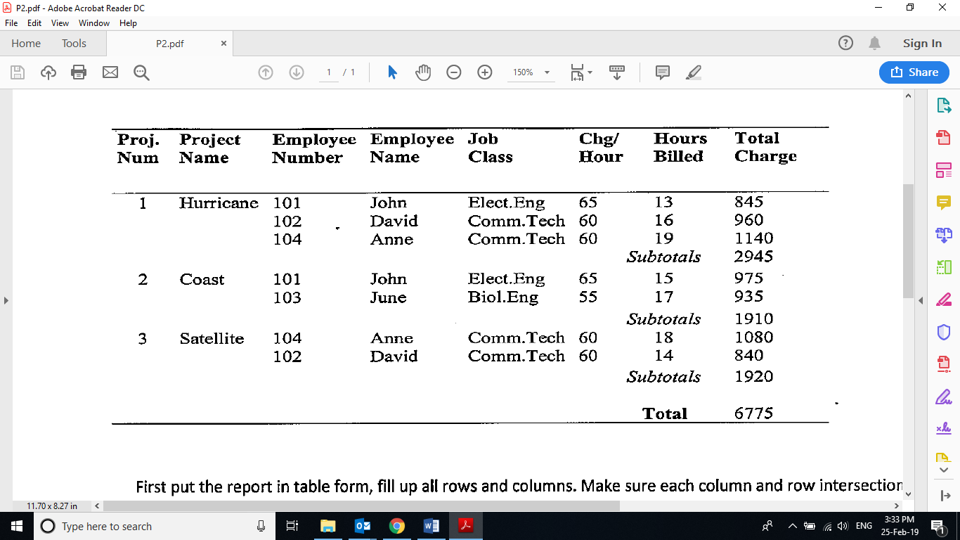

**Present the data in table form, fill up all rows and columns. Ensure each row and intersection has only one value (1mm)**

Redundancy

|  |  |  |  |  |  |  |  |  |
| --- | --- | --- | --- | --- | --- | --- | --- | --- |
| ProNum | ProName | EmpNum | EmpName | JobClass | ChgHour | HourBill | TotChar | SubTot |
| 1 | Hurricane | 101 | John | Elect.Eng | 65 | 13 | 845 | 2945 |
| 1 | Hurricane | 102 | David | Comm.Tech | 60 | 16 | 960 | 2945 |
| 1 | Hurricane | 104 | Anne | Comm.Tech | 60 | 19 | 1140 | 2945 |
| 2 | Coast | 101 | John | Elect.Eng | 65 | 15 | 975 | 1910 |
| 2 | Coast | 103 | June | Biol.Eng | 55 | 17 | 935 | 1910 |
| 3 | Satelite | 104 | Anne | Comm.Tech | 60 | 18 | 1080 | 1920 |
| 3 | Satelite | 102 | David | Comm.Tech | 60 | 14 | 840 | 1920 |

Identify Primary keys: **ProNum&EmpNum**

**Step 2: The table is now in first normal form (1NF)**

**Step 2: Change to second normal form (2NF)**

To identify the non-key attributes should form a table with which key attribute. (To reduce redundancy)

Primary keys: **ProNum&EmpNum** (in most cases, there will be more than 1 attributes known as composite PK)

Identify all dependencies. Remove partial dependency (exists when table has composite PK) (some ex may NOT have full dependency, but have pati depen

Make sure that each non-key attributes / non-determinant / non-PK is fully dependent on its determinant (PK)

Remain at original table

Form new table

Form new table

|  |  |  |  |
| --- | --- | --- | --- |
| Composite PK | Non-key attributes | Check List | Action |
| ProNum&EmpNum | ProName | Is ProName fully dependent on both (ProNum&EmpNum)?  Answer: No, ProName depend on ProNum, not EmpNum | Partial dependency exists. Remove ProName together with its determinant (ProNum) to form a new table. |
| ProNum&EmpNum | SubTot | Is SubTot fully dependent on both (ProNum&EmpNum)?  Answer: No, SubTot depend on ProNum, not EmpNum | Partial dependency exists. Remove SubTot together with its determinant (ProNum) to form a new table. |
| ProNum&EmpNum | EmpName | Is EmpName fully dependent on both (ProNum&EmpNum)?  Answer: No, EmpName depend on EmpNum, not ProNum | Partial dependency exists. Remove EmpName together with its determinant (EmpNum) to form a new table. |
| ProNum&EmpNum | JobClass | Is JobClass fully dependent on both (ProNum&EmpNum)?  Answer: No, JobClass depend on EmpNum, not ProNum | Partial dependency exists. Remove JobClass together with its determinant (EmpNum) to form a new table. |
| ProNum&EmpNum | ChgHour | Is ChgHour fully dependent on both (ProNum&EmpNum)?  Answer: No, ChgHour depend on EmpNum, not ProNum | Partial dependency exists. Remove ChgHour together with its determinant (EmpNum) to form a new table. |
| ProNum&EmpNum | HourBill | Is HourBill fully dependent on both (ProNum&EmpNum)?  Answer: Yes, HourBill depend on both (ProNum&EmpNum) | Full dependency exists, therefore no action needed.  HourBill remains in the original table with its determinant (ProNum&EmpNum) |
| ProNum&EmpNum | TotChar | Is TotChar fully dependent on both (ProNum&EmpNum)?  Answer: Yes, TotChar depend on both (ProNum&EmpNum) | Full dependency exists, therefore no action needed.  TotChar remains in the original table with its determinant (ProNum&EmpNum) |

Partial dependency – exists when the non-key attribute is dependent on some of the key attribute.

studentName depends on TPnumber or that TPnumber determines studentName

TPnumber > studentName, email, it means that given the TPnumber, we can find the studentName.

However, not studentName>TPnumber

Full dependency – exists when the non-key attribute is dependent on all of the key attribute.

Ex: In APU, if the admin want to find the exam mark/grade for a particular student of a particular module, do we use TPnumber or moduleCode or both TPnumber & moduleCode. TPnumber and moduleCode determines examMark/grade, meaning examMark/Grade depends on TPnumber & moduleCode

TPnumber & moduleCode > examMark/grade

Ex: PK – attribute A, attribute B, attribute C

Non-PK: attribute X, attribute Y, attribute Z

If X depends on A or A determine X, so is this Full or partial dependency?

This is partial dependency

If Y depends on B&C determine Y, so is this Full or partial dependency?

This is partial dependency

If Z depends on A&B&C, or A&B&C depends on Z, so is full or partial dependency?

This is partial dependency

**Step 2: Tables in second normal form (2NF)**

|  |  |  |
| --- | --- | --- |
| ProNum | ProName | SubTot |
| 1 | Hurricane | 2945 |
| 2 | Coast | 1910 |
| 3 | Satelite | 1920 |

|  |  |  |  |
| --- | --- | --- | --- |
| EmpNum | EmpName | JobClass | ChgHour |
| 101 | John | Elect.Eng | 65 |
| 102 | David | Comm.Tech | 60 |
| 103 | June | Biol.Eng | 55 |
| 104 | Anne | Comm.Tech | 60 |

Try to put the unnecessary redundancy another table

|  |  |  |  |  |
| --- | --- | --- | --- | --- |
| ProNum | EmpNum | HourBill | TotChar | SubTot |
| 1 | 101 | 13 | 845 | 2945 |
| 1 | 102 | 16 | 960 | 2945 |
| 1 | 104 | 19 | 1140 | 2945 |
| 2 | 101 | 15 | 975 |  |
| 2 | 103 | 17 | 935 |  |
| 3 | 104 | 18 | 1080 |  |
| 3 | 102 | 14 | 840 |  |

Better to do it this way cleaner ^

**The tables are now in second normal form (2NF)**

**3 step: Convert to third normal form (3NF)**

Identify transitive dependency (if any) then remove it, else the tables are already in third normal form (3NF)

Transitive dependency occurs when a non-key attribute is dependent on another non-key attribute

In this example, transitive dependency exists: EmpNum > JobClass > ChgHour (ChgHour is transitively dependent on EmpNum)

ChgHour (which is a non-key attribute) is dependent on JobClass (which is also a non-key attribute), because JobClass determines ChgHour

Therefore, remove JobClass & ChgHour to form a new table. However, JobClass need to remain in Employee table as a reference

**3 step: Tables in third normal form (3NF)**

|  |  |  |
| --- | --- | --- |
| ProNum | ProName | SubTot |
| 1 | Hurricane | 2945 |
| 2 | Coast | 1910 |
| 3 | Satelite | 1920 |

|  |  |  |
| --- | --- | --- |
| EmpNum | EmpName | JobClass |
| 101 | John | Elect.Eng |
| 102 | David | Comm.Tech |
| 103 | June | Biol.Eng |
| 104 | Anne | Comm.Tech |

|  |  |  |  |
| --- | --- | --- | --- |
| ProNum | EmpNum | HourBill | TotChar |
| 1 | 101 | 13 | 845 |
| 1 | 102 | 16 | 960 |
| 1 | 104 | 19 | 1140 |
| 2 | 101 | 15 | 975 |
| 2 | 103 | 17 | 935 |
| 3 | 104 | 18 | 1080 |
| 3 | 102 | 14 | 840 |

|  |  |
| --- | --- |
| JobClass | ChgHour |
| Elect.Eng | 65 |
| Comm.Tech | 60 |
| Biol.Eng | 55 |

**The tables are now in third normal form (3NF), normalization process ends.**

**Now you can implement the database in the DBMS, you can make further changes to the tables in 3NF such as below**

**Implement the tables in database server**

Identify PK & FK

**Project Employee**

|  |  |  |
| --- | --- | --- |
| ProNum (PK) | ProName | SubTot |
| 1 | Hurricane | 2945 |
| 2 | Coast | 1910 |
| 3 | Satelite | 1920 |

|  |  |  |
| --- | --- | --- |
| EmpNum (PK) | EmpName | JobClassID (FK) |
| 101 | John | J01 |
| 102 | David | J02 |
| 103 | June | J02 |
| 104 | Anne | J03 |

**ProjectWork Rate**

|  |  |  |  |  |
| --- | --- | --- | --- | --- |
| ID (PK) | ProNum (FK) | EmpNum (FK) | HourBill | TotChar |
| 01 | 1 | 101 | 13 | 845 |
| 02 | 1 | 102 | 16 | 960 |
| 03 | 1 | 104 | 19 | 1140 |
| 04 | 2 | 101 | 15 | 975 |
| 05 | 2 | 103 | 17 | 935 |
| 06 | 3 | 104 | 18 | 1080 |
| 07 | 3 | 102 | 14 | 840 |

|  |  |  |
| --- | --- | --- |
| JobClassID (PK) | JobClass | ChgHour |
| J01 | Elect.Eng | 65 |
| J02 | Comm.Tech | 60 |
| J03 | Biol.Eng | 55 |

1. Cart must have a storing system
2. Cart to order one to many
3. Cart